Getting ready to sell or buy? StraightPath Consulting in coordination with Granite Home Inspection meets your needs.

Covering Northern & Central Virginia including the Valley.

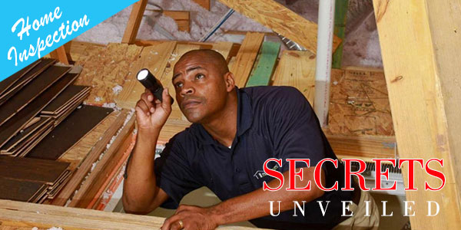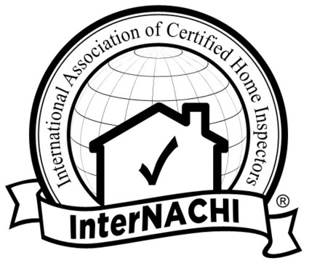

This Photo by Unknown Author is licensed under CC BY-NC-ND

