Flagging Certification

Beginning January 2025 all Flagging Certification will have to go through ATSSA or a course approved by VDOT.
StraightPath Consulting, LLC is working toward a Flagging Instructor Trainer Certification and should have it complete by April 2024.

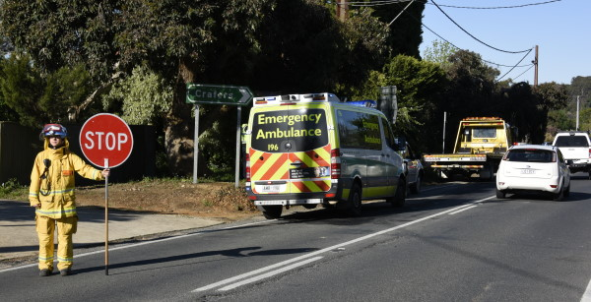
This Photo by Unknown Author is licensed under CC BY-SA

